Students of the Month for
March 2016

7th | Paxton Nichol  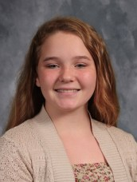
8th | Nathan Shrum  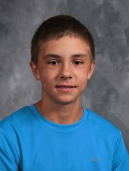
9th | Chett Miles  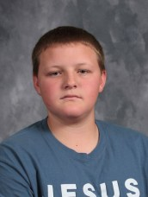
10th | Logan Seabaugh  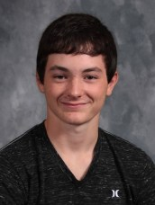
11th | Devin Wilfong  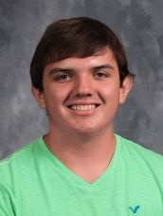
12th | Cherokee Long

